Running MOTHUR on Gorilla Server

Notes: you must be on a campus computer hooked into a PHYSICAL INTERNET CONNECTION. Yes, you can technically do this over wifi but if it drops for a second you will lose EVERYTHING from that session. After the completion of each command in mothur everything is saved and new files are created. Do not delete anything unless you know exactly what you are doing.

1. Open MobaXterm

(download and install if needed) <https://mobaxterm.mobatek.net/>

1. Start new session

Enter IP address (10.20.9.178)

Login in sdunn

Password:sdunn

You will see something like the following

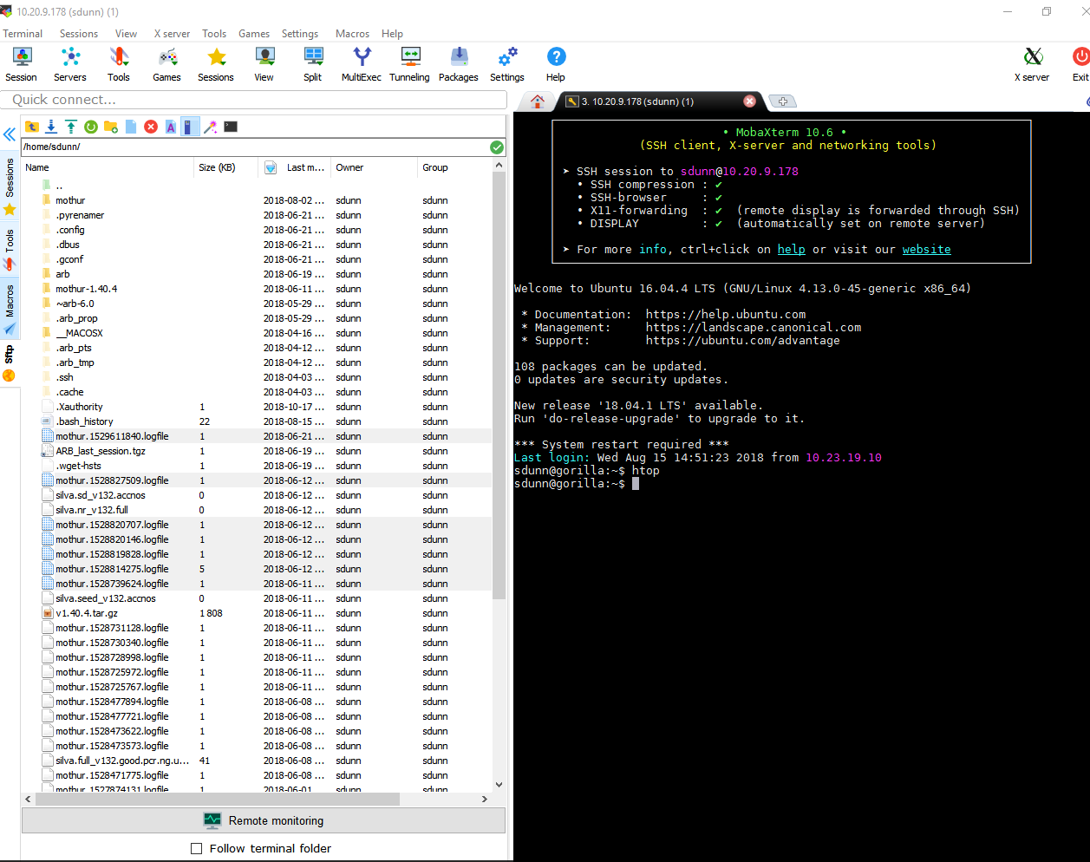

1. Make a new file in the mothur directory for your work. You can upload your .gz files to this directory and you will do all work in this directory so remember the name and path! For example /home/sdunn/mothur/NBC16s is where I did my bacterial work.

## Check the System

This is a shared machine! Make sure nobody is using it and figure out how many cores are available by typing “htop” into he command line in the black half of the screen. This will pull up an overview page of the system. There are 56 processors and 256Gb of Ram. More cores are better, but it’s courteous to use what is available. If there is too much demand on the computer it will overheat and shut down. Hit F10 to close this window

##Starting Mothurn from the command line (black panel)

sdunn@gorilla:~$ <= should look like this. Commands always follow the $

enter:

cd mothur

#you are saying to make the current directory “mothur”

enter the following to start running Mothur v1.40.4

./mothur

#mothur lives in the mothur directory, so we enter the command mothur to start it. The ./ are very important!

You should see something like this:

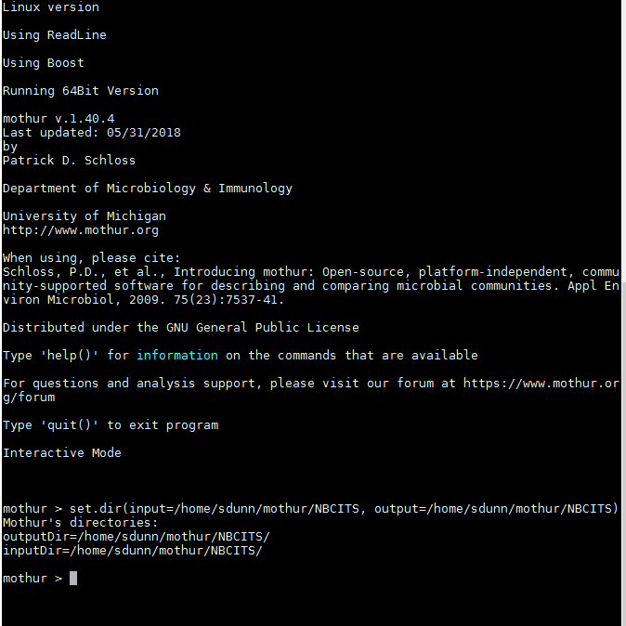

Now we need to tell mothur that we will be working in the directory you just made (commands entered in picture above)

**set.dir(input=/home/sdunn/mothur/NBCITS, output=/home/sdunn/mothur/NBCITS)**

If successful you’ll get the following:

Mothur's directories:

outputDir=/home/sdunn/mothur/NBCITS/

inputDir=/home/sdunn/mothur/NBCITS/

Now you can begin your mothur run! Follow the appropriate workthrough on this repository and don’t forget about the mothur wiki!